**PyCitySchools Challenge**

**Overview**

This challenge is designed for you to find the changes for the reading and math grades for Thomas High School ninth graders. This challenge required to remove the freshman reading and math scores, then analyze the rest data by repeating the analysis from Module 4 project.

**Results**

**How is the district summary affected?**

Before cleaning up



After cleaning up

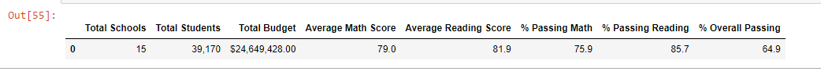

District is showing a slightly decrease after cleaning up data.

**How is the school summary affected?**

Thomas High School Overall passing rate decreased from 90.948012 to 90.630324.

Before cleaning up

After cleaning up

**How does replacing the ninth graders’ math and reading scores affect Thomas High School’s performance relative to the other schools?**

Removing ninth graders’ math and reading scores not significantly change the Thomas High School’s performance.

**How does replacing the ninth-grade scores affect the following:**

* **Math and reading scores by grade**

The removal of Thomas High School ninth graders’ math and reading scores does not affect the other schools’ data set.

Before cleaning up- Math

After cleaning up- Math

Before cleaning up-reading

After cleaning up-Reading

* **Scores by school spending**

The Overall Passing rate for $585-629 per student increase from 81% to 90% after data cleaning up.

The Overall Passing rate for $630-$644 per student increase from 63% to 66% after data cleaning up.

Before cleaning up

After cleaning up

* **Scores by school size**

The cleaning up data has very slight influence on scores by school size.

* **Scores by school type**

The data cleaning up has very slight influence on the scores by school types.

Before cleaning up

After cleaning up

**Summary**

From the analysis applied to this challenge, we can see the reading and math scores replaced would have slightly changes to different aspects. After comparison, we can summarize that replacing the data would help the analysis more accurate, based on the size of the data set, removing ninth graders’ math and reading scores of Thomas High School would not have huge influence on the district summary, scores by school spending, scores by school size and scores by school type.